Task on S3:
1.Create an S3 bucket and upload some objects to S3:
Created a bucket by going through the Create Bucket Section.
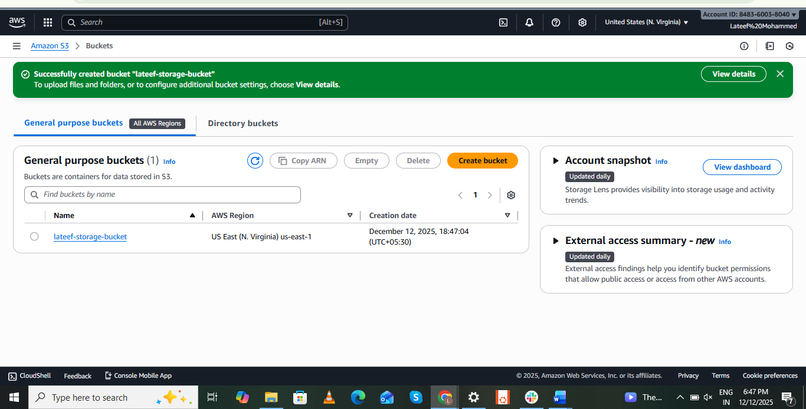
Added object to S3.
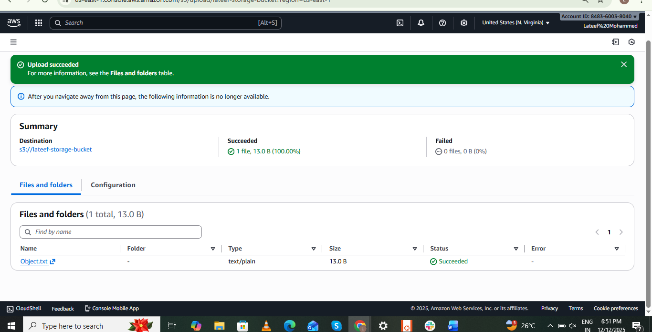
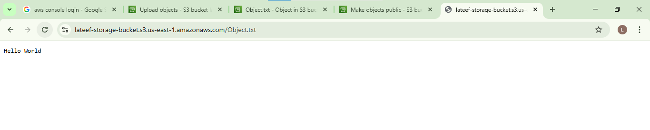

2.Deploy a static website in the S3 bucket:
Created a file using the command “touch filename”
1.test.html
2.error.html
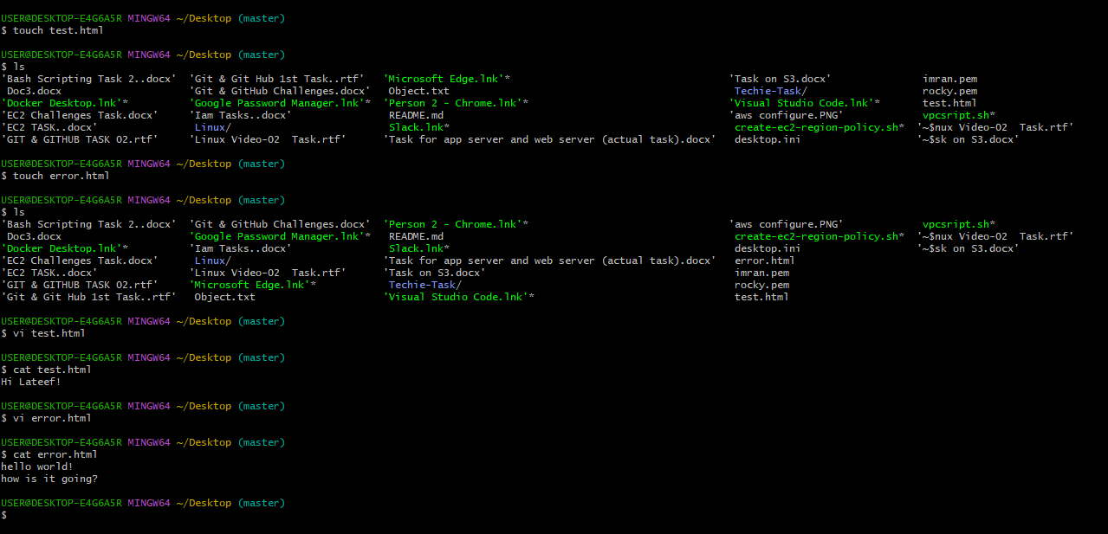
Uploaded the two .html files in a object section, successfully.
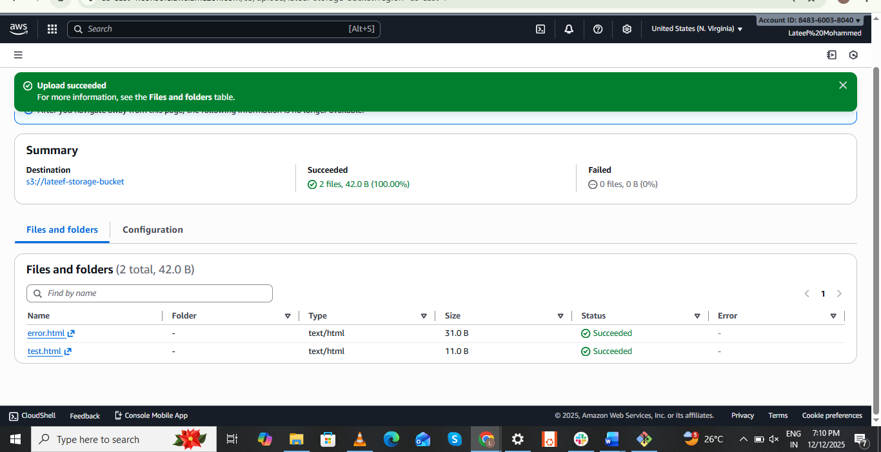
Deployed successfully on static website.
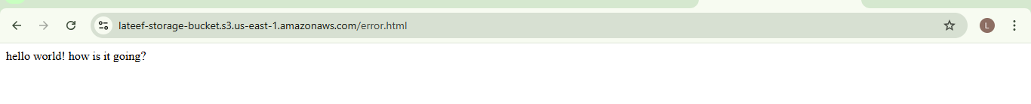
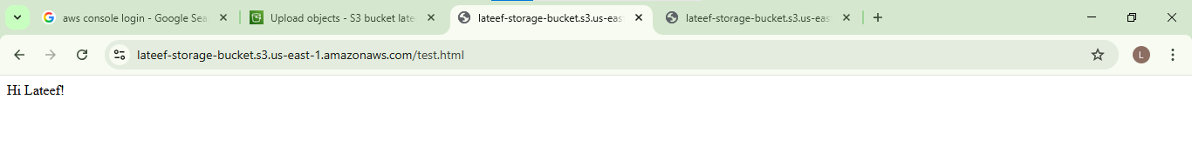

3.Enable cross-region replication on S3 buckets:
Created a bucket in a N. virginia region.
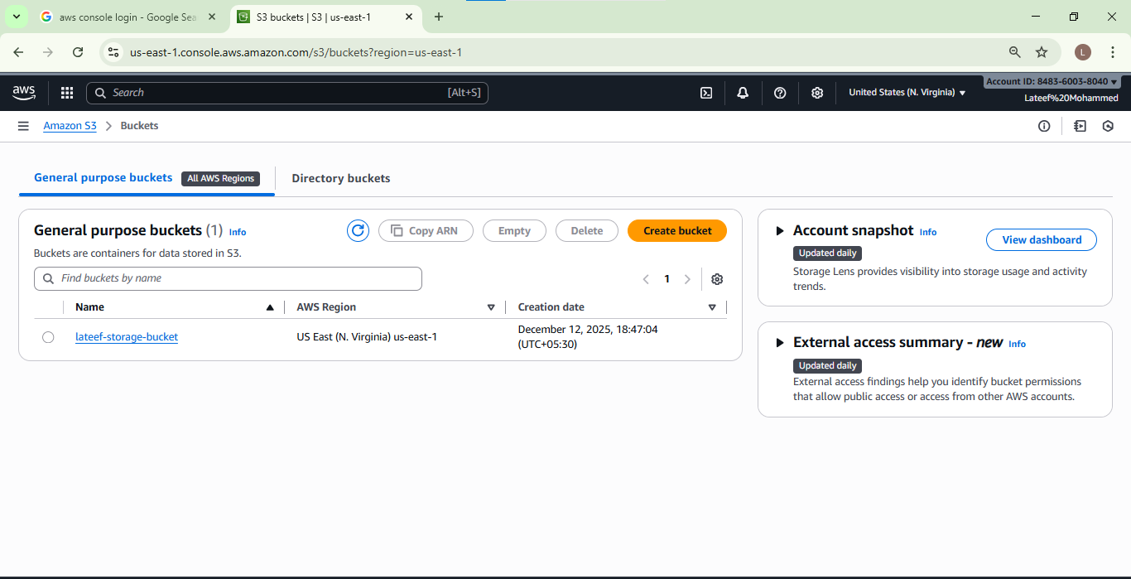
Created a bucket in a Frankfurt region.

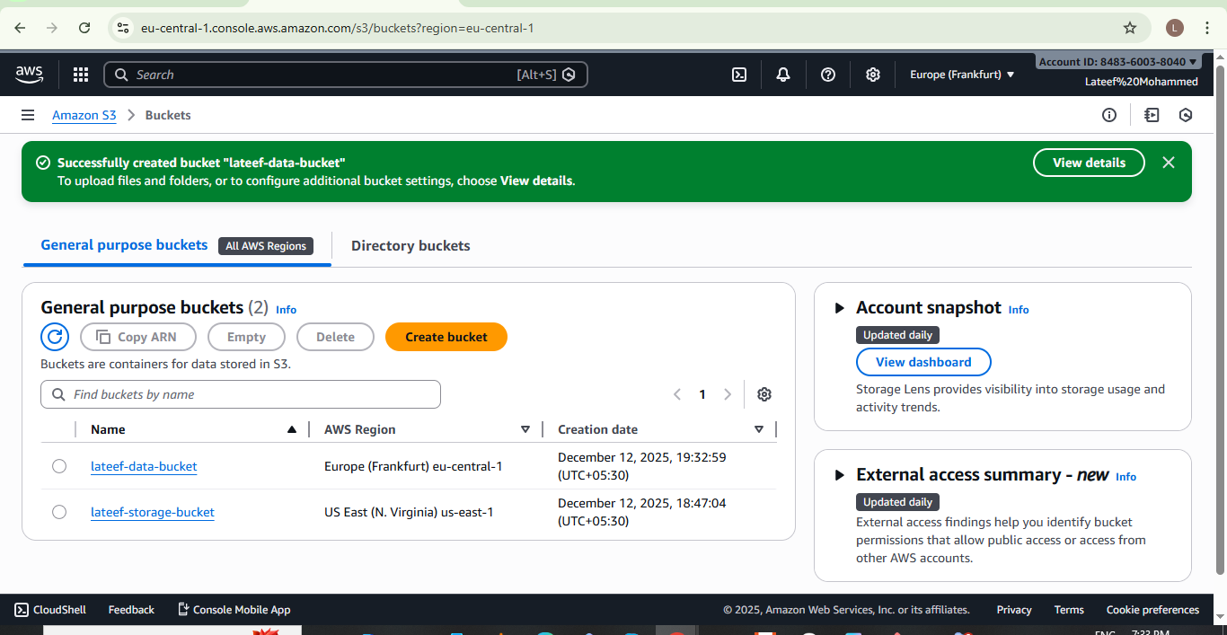
Bucket versioning enabled successfully.
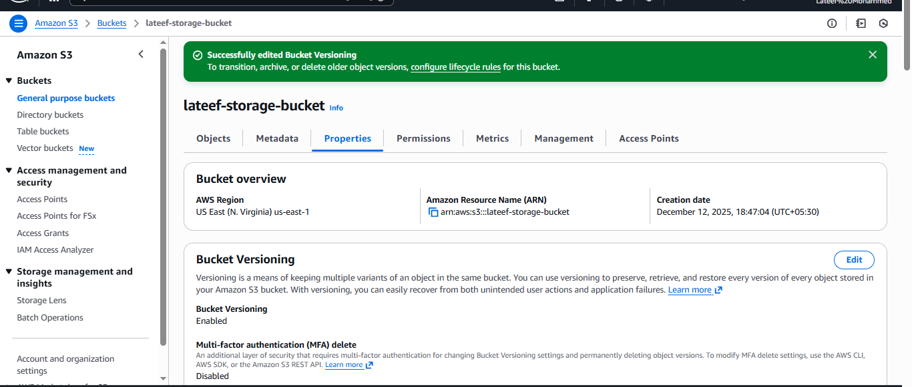
Creating a Replication Rule by giving a Name as My-Replication rule.
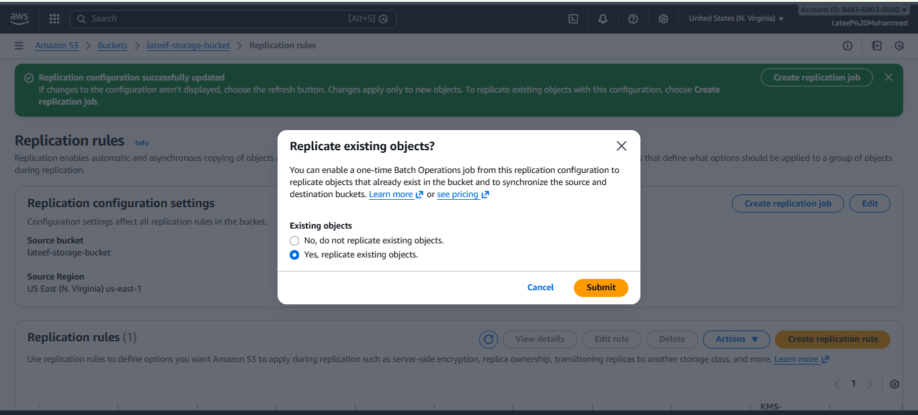Now, we can see the replication rule is set.

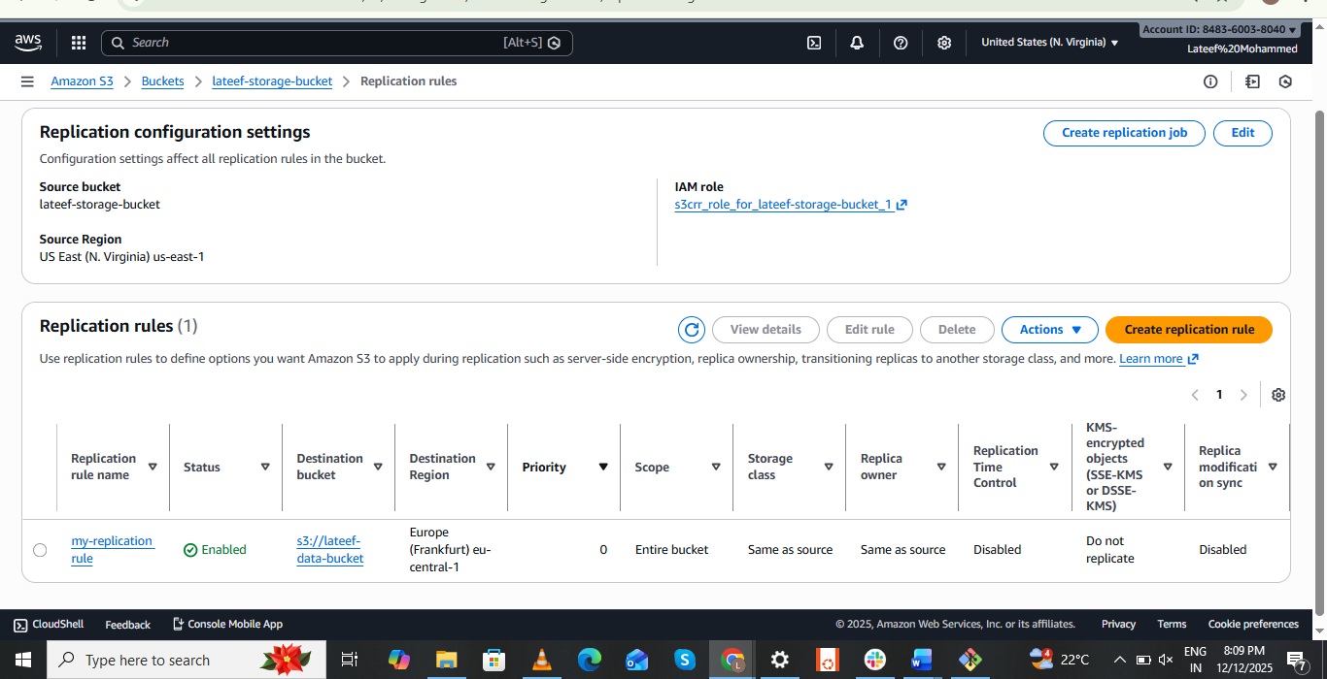
Now, everything is set. Let’s verify and test.
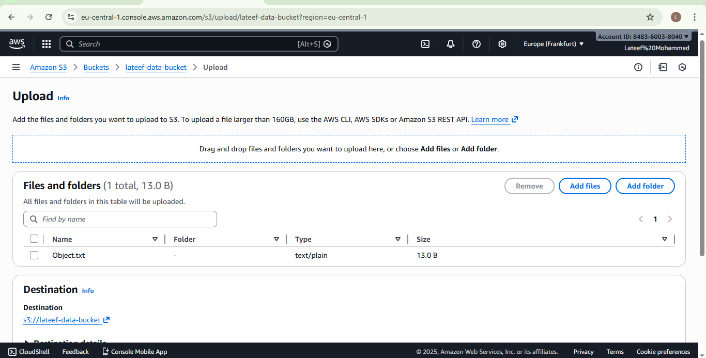
Success. I can verify the Frankfurt region bucket and can see the object present. Please see the below screenshot.
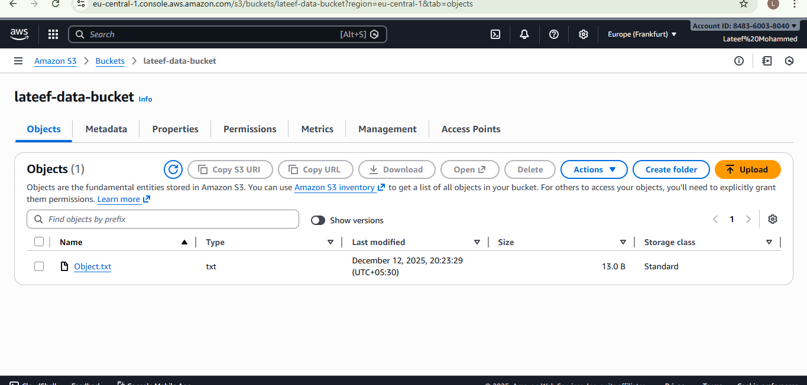
6.Push some objects to S3 using the AWS CLI:
Steps to pushing few objects to S3 using CLI.
Navigate to a terminal.
Use commands- aws configure.
Enter access key details.
Aws s3 ls- to retrieve the buckets available.
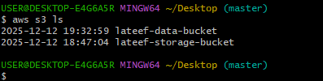
aws s3 cp /c/Users/lateef/Downloads/GitHub-02 s3://lateef-data-bucket / --recursive- this will copy the GitHub-02 name folder and will store in vicky-root-007 named bucket.
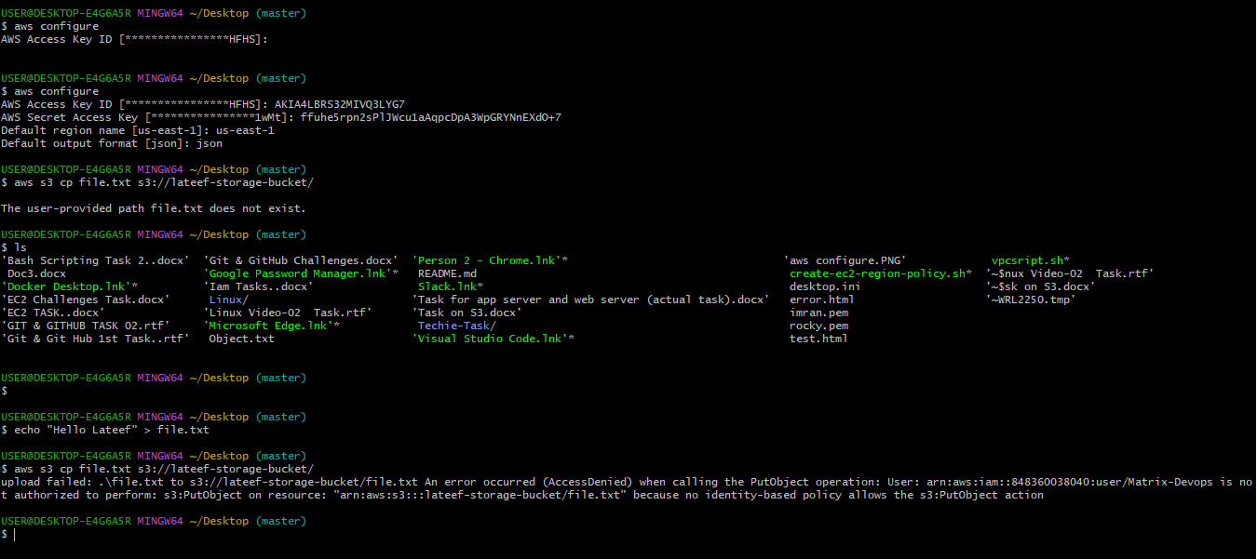
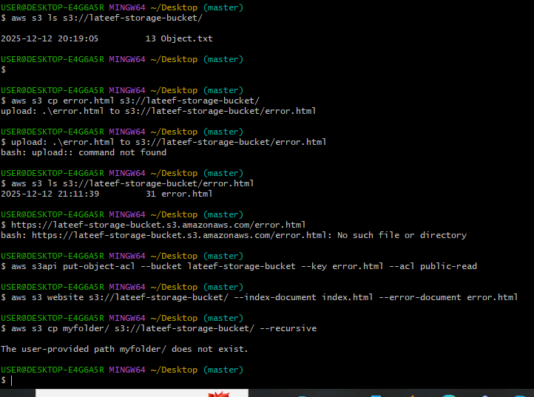
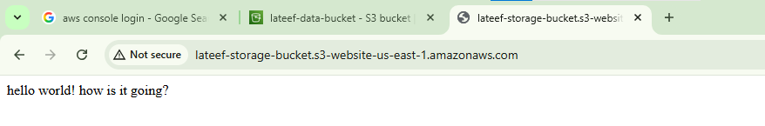
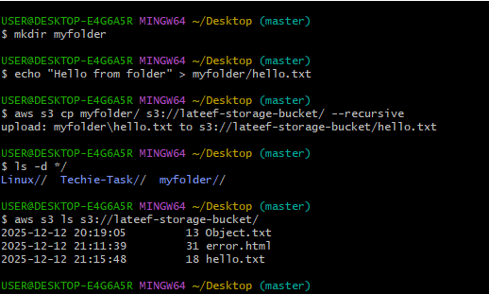
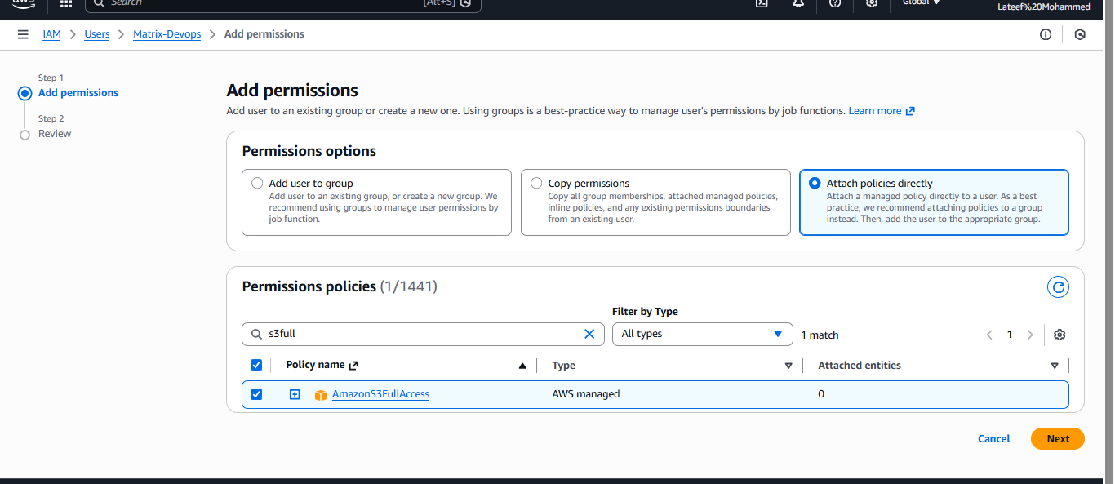
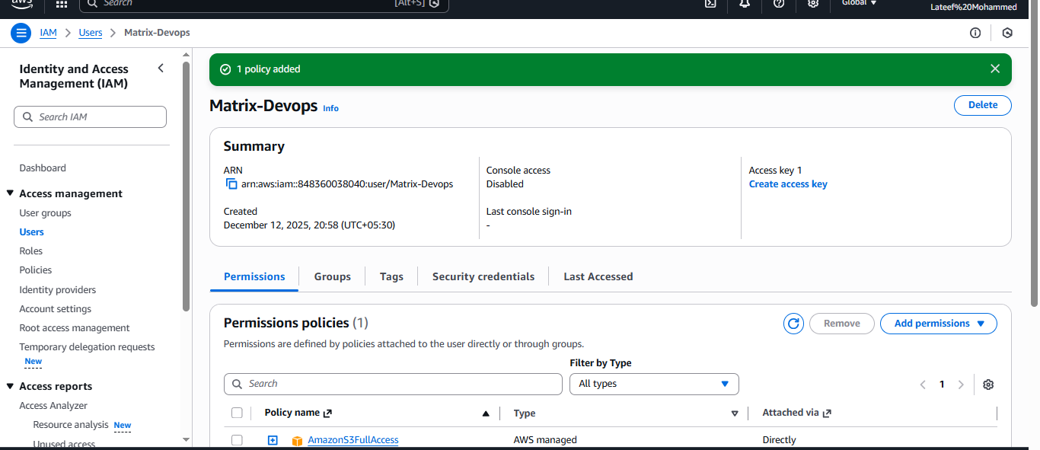Now, finally we can see all the objects have been uploaded to my bucket-lateef-data-bucket.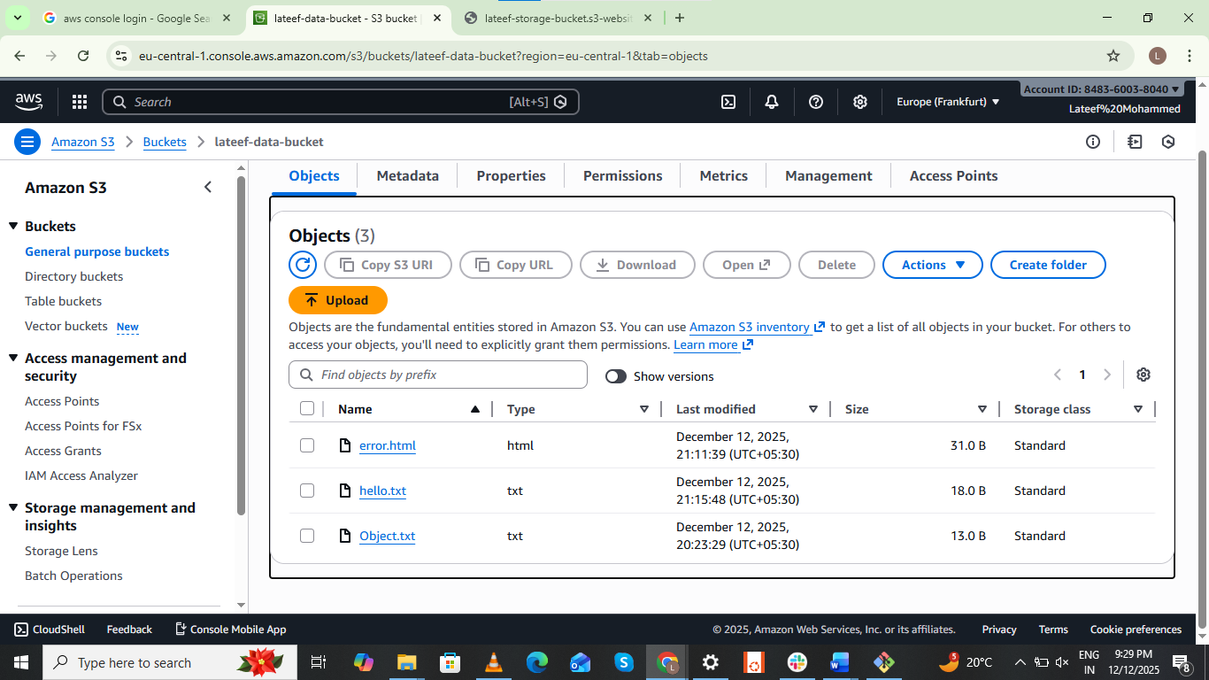

8.Upload a 1 GB file to S3 using the CLI:
Created the 1gb file in s3 bucket by using the CLI.
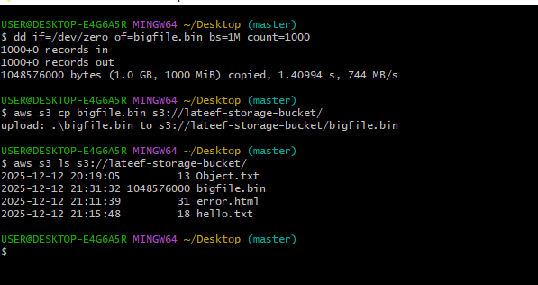
Successfully file is created 1gb file

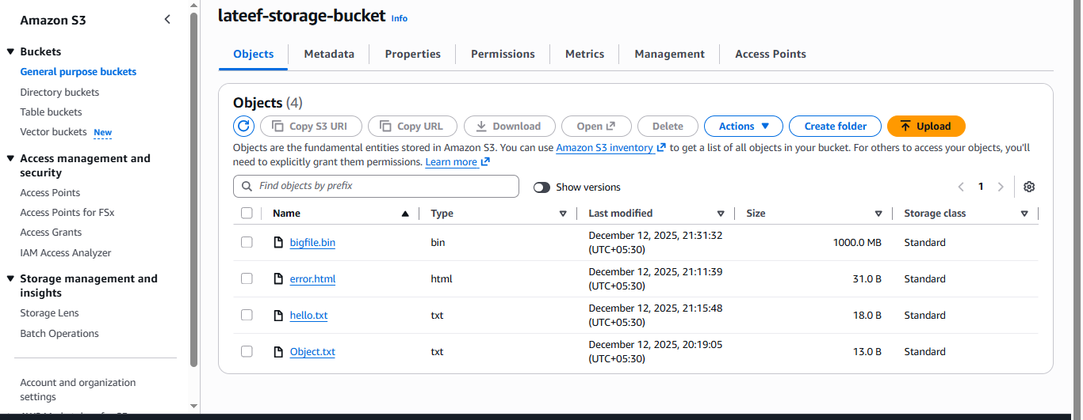

7.Write a Bash script to create an S3 bucket:
Created a bucket in S3 using a script as per below screenshot.
Provided permissions using command- chmod +x Aws_s3.sh
Executed the script - Aws_s3.sh
Successfully the script got executed and verified that a bucket got created with the name- lateef-data-bucket.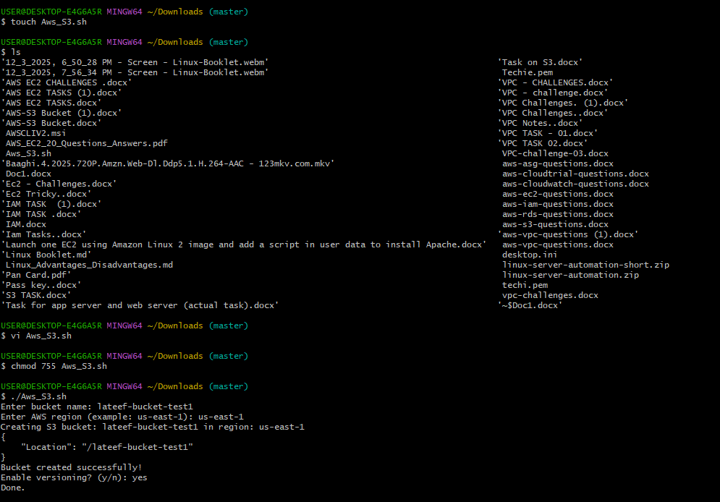Verified in s3 bucket and noticed that a new bucket was created.